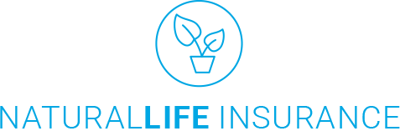

|  |  |
| --- | --- |
| Name | Kate Smith |
| Address | 8-17-1 Nishi-Shinjuku, Shinjuku-ku |
| City | Tokyo |
| Country | Japan |
| Phone | (+81)-3-5337-6502 |
| E-mail | [signpro.pdf@API.com](mailto:signpro.pdf@API.com) |
| Customer ID | 123456 |

NaturalLife Insurance  
4 Chome-2-8 Shibakoen  
Minato, Tokyo 105-0011  
Japan

This **Dental Insurance Contract** (the “contract”) is effective as of **22.10.2018** (“Effective Date”) by and between NaturalLife Insurance having a principal place of business at 4 Chome-2-8 Shibakoen, Minato, Tokyo 105-0011, and **Kate Smith** as identified hereunder.

BY SIGNING ON THE ‘CONTRACT’ BELOW, YOU ACKNOLEDGE (1) YOU HAVE READ AND REVIEWED THIS CONTRACT IN ITS ENTIRETY ANY APPLICABLE TERMS AND CONDITIONS (3) THE INDIVIDUAL SO SIGNING HAS THE POWER, AUTHORITY, AND LEGAL RIGHT TO ENTER INTO THIS CONTRACT ON BEHALF OF YOU AND, (4) BY SO SIGNING, THIS CONTRACT CONSTITUES BINDING AND ENFORCEABLE OBLIGATIONS OF YOU.

|  |
| --- |
| {{[[Type=Signature,Name=ApprovalSignature,Signer=Kate Smith,Reason=Approval,Width=300,Height=100]]}}]] |

SIGNATURE